# EEE109 Lab 3

# Frequency Response of A BJT Amplifier

# (Lab Report)

**Student IDs:** *1928748*

**Submission date:** *Dec 16th, 2020*

### *Abstract*

*In this experiment, we will use LTspice simulation software to explore the frequency response of the BJT amplifier circuit. We will firstly plot the output characteristics of the BJT to find the magnitude of current gain β. Then, calculate the data in the circuit according to the requirements. Afterwards, construct the common emitter amplifier circuit and common collector circuit and simulate the Bode plots. Use Bode plot to analyze the relationship between frequency and magnification factor and find the 3dB point. In the end, there will list some possible suggestions which could help people to improve the experiment, so that we could obtain results closer to the real values.*

### Introduction

In electronic circuit, the performance of the amplifier is influenced by the frequency of the input signal. This kind of characteristics is known as frequency response [1]. It is one of the most important properties of amplifiers. Usually, we use the Bode plot to show the relationship between the voltage gain and the frequency. We will use the simulation software LTspice to do this experiment. We will firstly find the current gain β at a certain value of IC. Then, we will calculate all the experimental data according to the requirements. After that, we utilize the calculated data and the original data to construct the circuit and simulate the Bode plot. There will be a discussion after the “Results and Calculation” part, which will talk about some methods that may reduce errors. Finally, there will be a conclusion to summarize this experiment and give some advice that may help other people to do this experiment.

### Theory

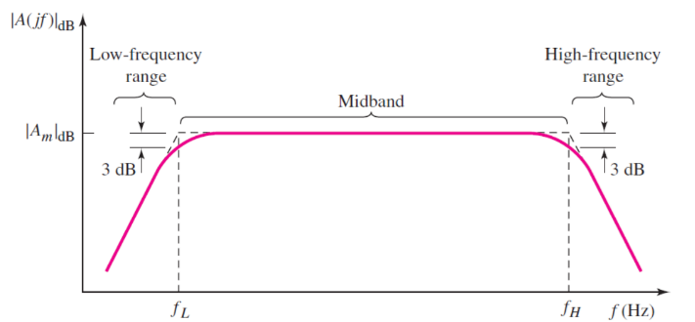In the amplifier circuit, due to the existence of electrical impedance components, such as capacitors, inductors and inter-pole capacitors of semiconductors, when the frequency of the input signal is too low or too high, not only the magnification will become smaller, but also the phase shift of lead or lag will be produced [1]. Therefore, it is important to consider the influence of the impedance components to the circuit frequency. Bode plot is a kind of method to analyse the frequency response of the circuit.

Figure 1: A sample of Bode plot

As Figure 1 shows, the Bode plot can be divided into three parts: Low-frequency range, Midband range and High-frequency range. “fL” is the lower corner frequency of the circuit while “fH” is the higher corner frequency of the circuit. When the circuit is in Low-frequency range, all bypass and coupling capacitors should be considered while all transistor and load capacitors are open-circuit. In high frequency range, the load and transistors should be included in. All bypass and coupling capacitors should be neglected. When the magnitude of the frequency is between fL and fH, all the capacitors can be ignored.

### Circuit Design

Figure 2: The circuit used to find β

In order to find the magnitude of the common-emitter current gain β, we should construct the circuit according to Figure 2.

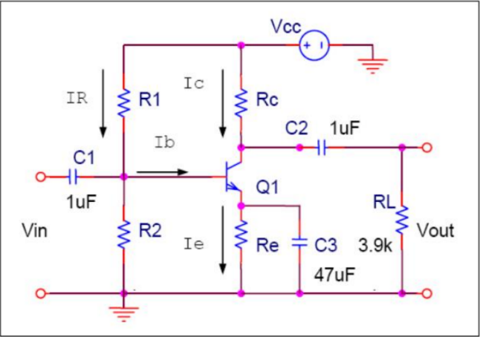Then, we should construct the common emitter amplifier circuit according to Figure 3.

Figure 3: The common emitter amplifier circuit

The magnitude of the unknown resistances will be discussed in the “**Results and Calculation**” part.

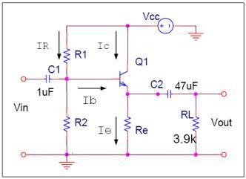After that, we need to construct the common collector circuit, which is shown in Figure 4.

Figure 4: The common collector circuit

The magnitude of the unknown resistances will be discussed in the “**Results and Calculation**” part.

### Experimental Method

We will use LTspice to do all the experiments.

To find the magnitude of the common-emitter current gain β, we should construct the circuit simulation software according to Figure 1. The components we need are current source, voltage source and 2N3904 NPN transistor. The current source is to simulate the base current. The voltage source is used to make the collector in reverse-biased region. After we construct the circuit, we can use the “DC sweep” function to plot the output characteristic waves of the BJT. Set Vce changes from 0V to 10V with the increment of 1V. After that, set Ib changes from 0A to 40μA with the increment of 5μA. Find the value of Ib when Ic is equal to 5mA and calculate the magnitude of β.

To construct the common emitter amplifier circuit, we need five resistors R1, R2, Rc, Re and RL. The function of R1 and R2 is to make sure the small signal will not be cut-off by the BJT. Rc is the current limiting resistance which is used to transfer the current signal into voltage signal. Re is the feedback resistance. It is used to stable the Q point of the BJT. RL is load resistance, we can obtain the signal by measuring the voltage between them. C1 and C2 are coupling capacitor. C3 is the bypass capacitor. The magnitude of Vcc is 10V and the value of small signal AC source is 0.02V. After construct the circuit, we can use the “AC analysis” function to draw the Bode plot. Set the type of sweep to “Decade”. The start frequency is 10Hz and the stop frequency is 10GHz. Number of points per

For the common collector circuit, we require three resistors R1, R2 and Re. The use of these three resistors are similar to the common emitter amplifier. C1 and C2 are coupling capacitors. We also use “AC Analysis” function to draw the Bode plot. Set the frequency from 1Hz to 300GHz.

### Results and Calculation

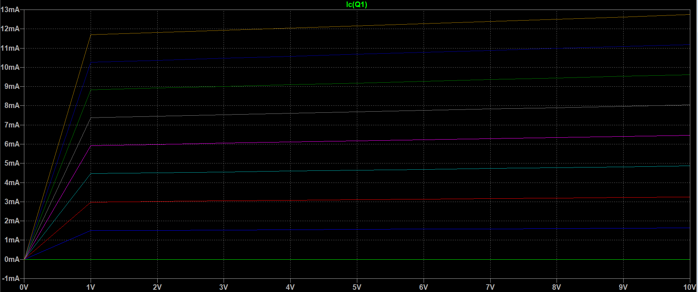To find the value of β, we require to plot the output characteristic wave of the BJT. Figure 5 shows the output characteristics.

Figure 5: The output characteristics

When IC = 5mA, the magnitude of IB is about 15μA. Thus, the magnitude of β = IC/IB ≈ 333.33.

Then, we can calculate the magnitudes of resistances in the common emitter amplifier circuit, which is shown in Figure 6. In this experiment, we use the 2N3904 BJT. We can obtain that the value of Early voltage VA is about 100V.

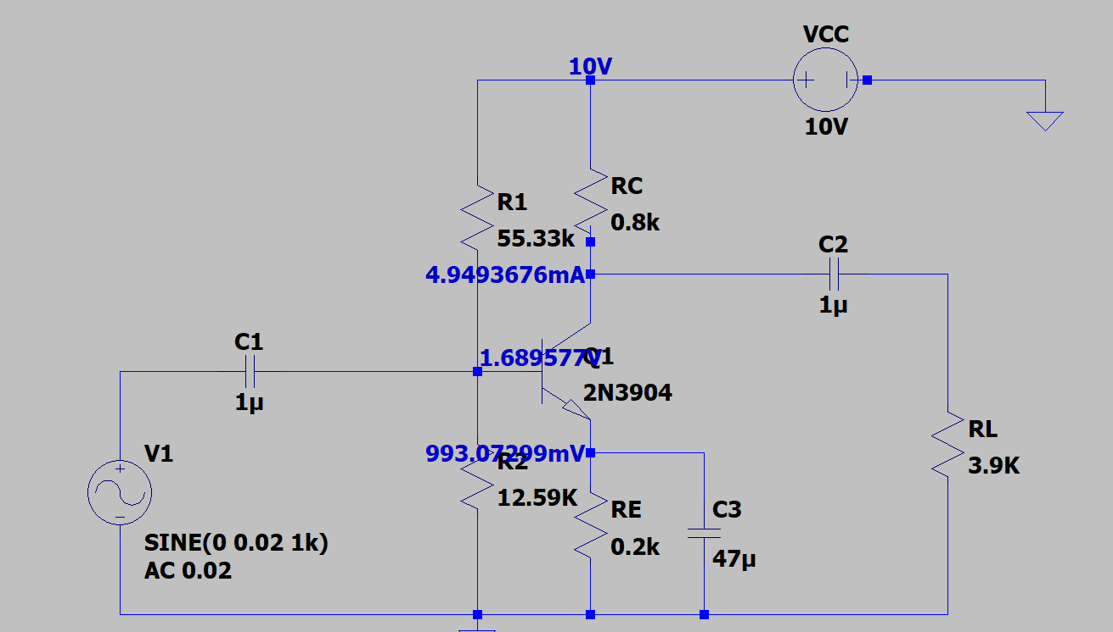Figure 6: Common emitter amplifier circuit

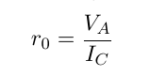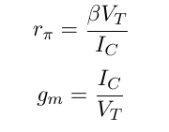The value of rπ is about 1.7322kΩ and gm is about 192.31mA/V. The value of r0 is about 20kΩ.

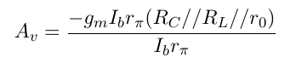The voltage gain is about 123.59

The input resistance is about 1.482kΩ, which is the value of (rπ // R1//R2).

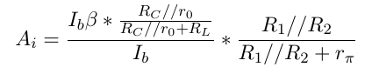The current gain Ai is about 46.98

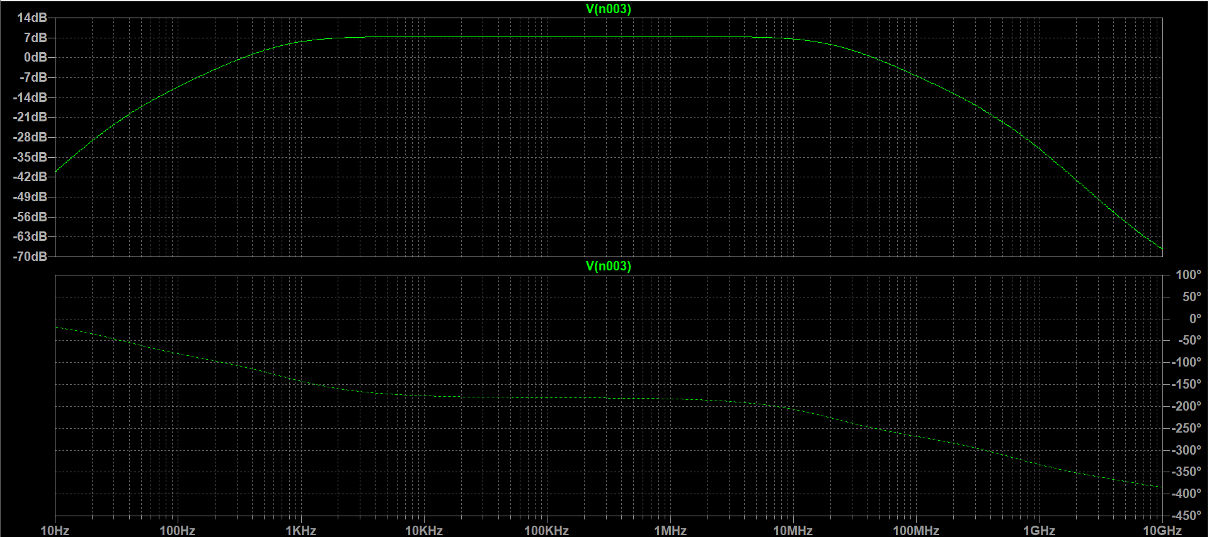The Bode plots is shown in Figure 7

Figure 7: The Bode plots

From Bode plot we can easily find the low frequency range, high frequency range and the Midband range.

From the phase plot, we can find the phase changes in different magnitude of frequency. When the circuit frequency is in Midband range, the phase changes very slowly.

The 3dB point for lower frequency is about 729.9Hz. The 3dB point for higher frequency is about 20.664MHz.

For common collector amplifier circuit, the resistance value is shown in Figure 8. 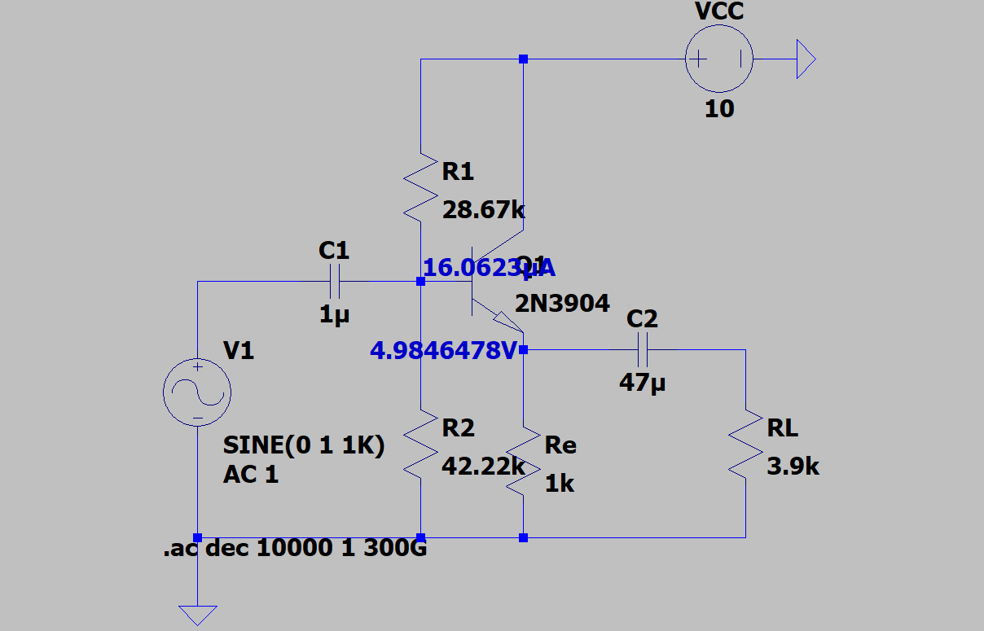

Figure 8: The common collector amplifier circuit

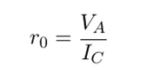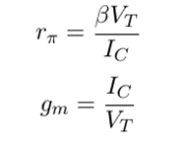The value of rπ is about 1.7322kΩ and gmis about 192.31mA/V. The magnitude of r0 is about 20kΩ.

The input resistance is about 16.014kΩ.

The output resistance is about 5.16Ω.

The current gain Ai is about 4.074

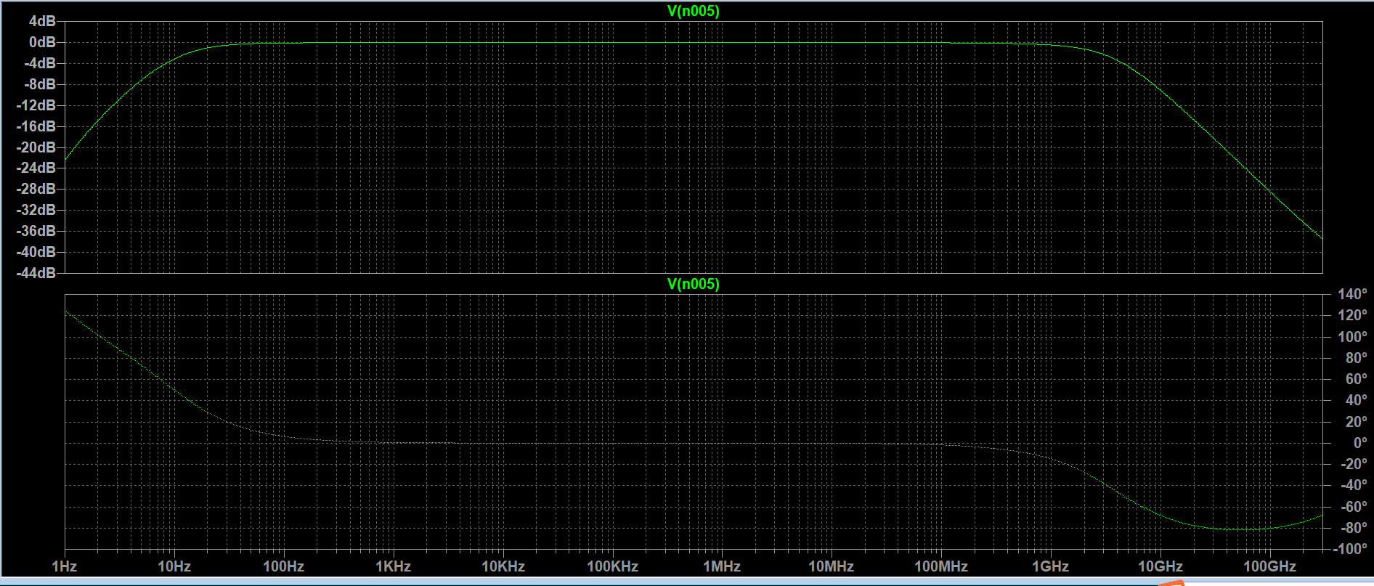The Bode plots is shown in Figure 9

Figure 9: The Bode plots

We can find that the Shape of the two graphs is quite similar to the common emitter amplifier circuit results.

The 3dB point for lower frequency is about 10.245Hz while for higher frequency is about 3.601GHz.

### Discussion

From the Bode plots, we can find how the magnitude of frequency will influence the circuit. Thus, we can conclude that we should control the circuit frequency in the Midband range so that we obtain the largest Magnification factor and reduce distortion.

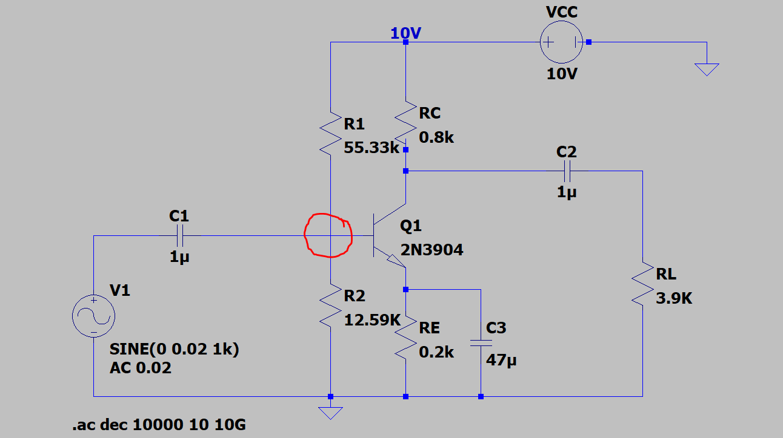The error may come from several aspects. The first one is the simulation calculation. For instance, we assume that the magnitude of IE is equivalent to IC; we also suppose that the current IR is ten times to the Ib. The approximate calculation could cause errors. We may try to use more real statistics in the future. The second one may be the choice of data. For example, when we try to find the value of β, we could consider the condition that Ic is equivalent to 6mA. When IC is equal to 6mA, the value of β is about 300. That is the ideal value for the transistor to work as an amplifier. What is more, you should check whether the circuit you constructed is correct. Otherwise, it may confuse you. When I first construct the circuit. I make a mistake which is shown in Figure 10.

Figure 10

You can see that there should be a node sign in the red circle, which means the two wires are connected. If there is no node, the small signal will be cut off by the BJT and there will be no response for the output. This mistake confused me for a long time. Thus, in the following experiments, we should check the circuit carefully.

### Conclusion

From this experiment, we learned how to use LTspice to simulate circuits. Simulation software can be very helpful when we deal with complex circuits. We use LTspice to plot output characteristics of BJT and find the current gain β. Then, we construct the common emitter amplifier circuit and common collector amplifier circuit. Then, depict the Bode plot of these two circuits. From Bode plots, we can find how the frequency will influence the voltage gain and how different capacitors work in different values of frequency. We can also use Bode plot to find the corner frequency, which is the 3dB point. Through analysing the Bode plot, we could reduce the influence of frequency to the circuit. In the following time, we could use more real values but not just approximation values to do the simulation experiment, so that we could obtain the experimental data, which is closer to the real value.

### References

[1] Electronics-lab, *FREQUENCY RESPONSE OF AMPLIFIERS,* 2018. [Online]. Available: <https://www.electronics-lab.com/article/frequency-response-amplifiers/> [Accessed Dec. 6, 2020].